Leave Management System

**Introduction**

The Leave Management System is an Internet based application that can be accessed throughout the organization or a specified group/Dept. This system can be used to automate the workflow of leave applications and their approvals. The periodic crediting of leave is also automated. There are features like email notifications, cancellation of leave, approval of leave, report generators etc in this Software. The project has been planned to be having the view of distributed architecture, with centralized storage of the database. The application for the storage of the data has been planned.

The standards of security and data protective mechanisms have been given a big choice for proper usage. The application takes care of different modules and their associated reports, which are produced as per the applicable strategies and standards that are put forward by the administrative staff.

It provides an easy way to apply for a leave. To apply for a leave an employee simply login to their account by using their login password and apply for leave. All the employees must have to provide a reason for the approval of leave. The status of their leave is also display on employee account

**PROBLEM IN THE EXISTING SYSTEM:**

* Cannot Upload and Download the latest updates.
* No use of Web Services and Remoting.
* Risk of mismanagement and of data when the project is under development.
* Less Security.
* No proper coordination between different Applications and Users.
* Fewer user friendly.

**SOLUTION OF THESE PROBLEM:**

The development of the new system contains the following activities, which try to automate the entire process keeping in view the database integration approach.

1. User friendliness is provided in the application with various controls.

2. The system makes the overall project management much easier and flexible.

3. Readily upload the latest updates, allowing users to download the alerts by clicking the URL.

4. There is no risk of data mismanagement at any level while the project development is under process. 5. It provides a high level of security with different levels of authentication.

**Tech Stack :**

**ReactJs** for Front-end.

**NodeJs & ExpressJs** for Backend.

**PostgreSQL** for Database.

**Persons using the Software and their accessibility:**

**Admin :**

* Has access to Database
* Has permission to remove users
* Has permission to change details of User
* Can create a new User

**User :**

* Apply for a Leave
* Approve the Leave for the user that report to them
* Forward the Leave request to Higher Authority.
* Reject the Leave Request.
* Change Password of their account.
* Update Details.

**UI Pages of the web app :**

**Sign In Page:**

This page contains two input sections, **Username/email** and **Password** which lets you sign in to the respective user account.

**Home:**

This is a Home Page which contains some details of the User and statuses of the user leaves and all. This page contains a Navbar in which u can navigate to other pages.

**Navbar:**

Navbar contains Links to navigate to other pages.

The pages that Navbar contains are :

1. Home
2. Update details
3. Change Password
4. Leave Form
5. Leave Requests
6. Leave History

**Update Details Page:**

This Page contains input sections where you can update your details.A user can only update his details.

**Change Password:**

This page is to change the password.

**Leave Form:**

This page contains a Form which needs to be filled to apply for a leave. The form contains inputs like Duration, Reason, Type of Leave etc.. and a Submit button to submit the request.

**Leave Requests:**

This page contains the list of requests the user received from the users that directly report to him.

He can Approve, Forward to Higher Authority, Reject the requests.

**Leave History:**

This page contains the List of the leaves a user applied and their statuses.

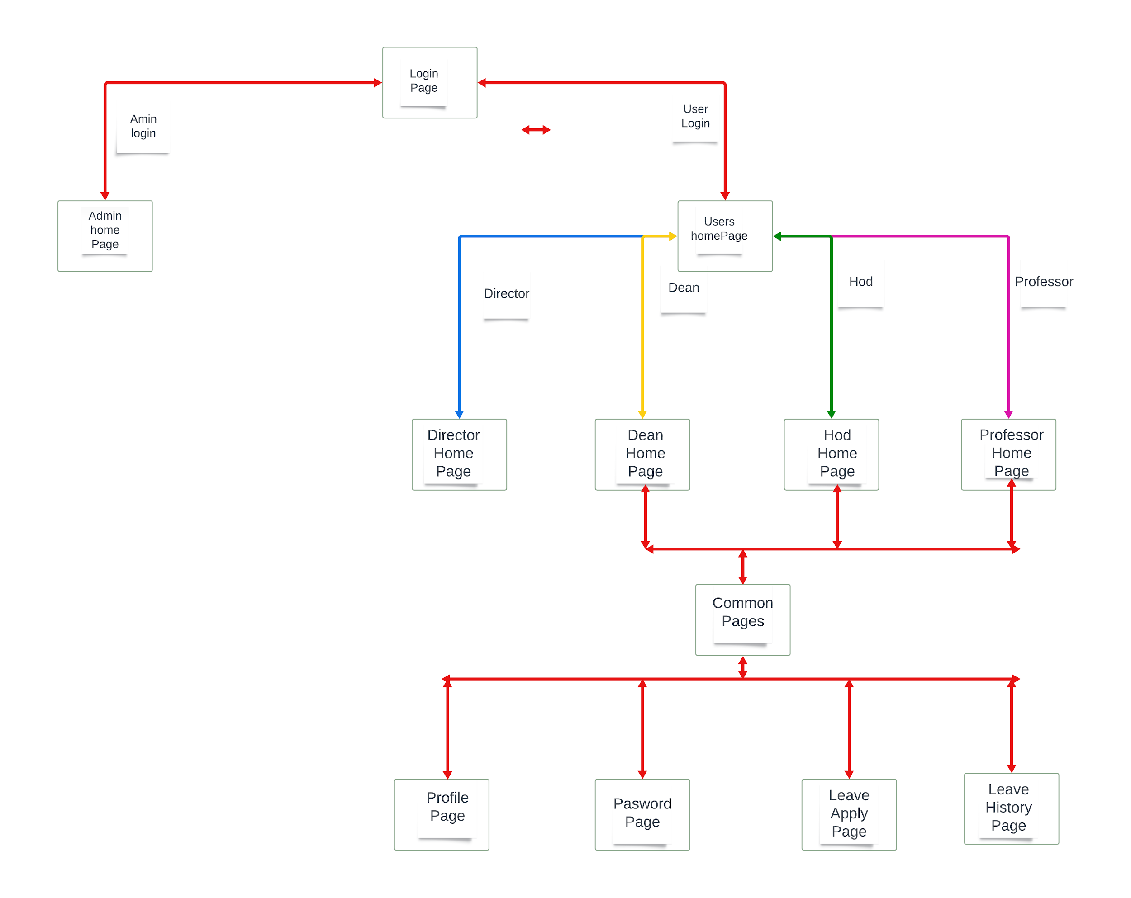

**Pages Navigation Diagram**